Success Story

NAME OF COMPANY
City, State
BUILDING PHOTO (if possible)
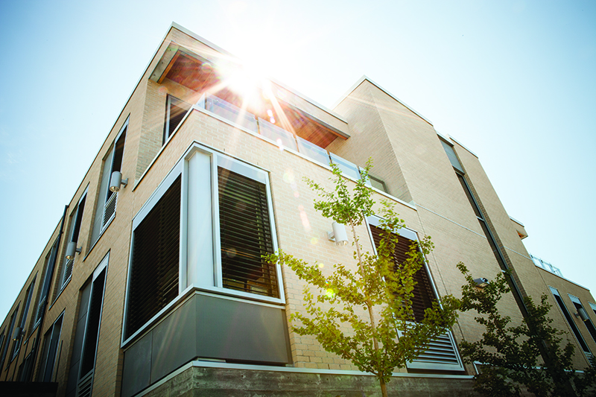
ENTER PROJECT INFORMATION HERE:
Name of project, description of project, etc.

Application Photos (if possible)

Number of Buildings: | 1 | Total Area: | 24375

Special Features:
LIST ANY SPECIAL FEATURES HERE

Products / Equipment Installed:
LIST PRODUCTS IN BULLET POINTS

Systems Integrated:
LIST SYSTEMS INTEGRATED:
EXAMPLE: (HVAC, Lighting, Power Monitoring, Security, Water Monitoring)

Number of Devices: | 184 | System Points: | 1068

Owner / Occupier: | LIST OWNER HERE IF POSSIBLE

System Integrator: | LIST SI HERE IF POSSIBLE

Engineering Firm: | LIST IF POSSIBLE

Consultants: | LIST IF POSSIBLE

Mechanical Contractor: | LIST IF POSSIBLE

BACnet Manufacturers: | LIST BACNET MANUFACTURERS HERE

LIST ADDITIONAL INFORMATION HERE:

